Homework 4: Confidence intervals and significance tests
due October 5, 2026 at 10:20 (upload to Pitch2Peer portal on Brightspace --> Week 4)
This assignment involves the (a) calculation of standard error of means (SEMs) and confidence intervals (CIs) for means of variables with continuous distributions, (b) tests of mean-level differences using independent and paired sample t-tests, and (c) reporting of CIs, t-tests, and chi-square analyses in APA style. The data set for this homework is parenting.sav, which includes adolescent self-reports of the following variables:

PARTNO participant number
Gender participant sex (female = 0, male = 1)
Response parental responsiveness (low = 0, high = 1)
Demand parental demandingness (low = 0, high = 1)
Psycho psychopathic traits (ranges from low = 10 to high = 60)
Problems internalizing and externalizing behaviors (ranges from low = 0 to high = 25)
Neurotic neuroticism (ranges from low = 0 to high = 25)

Part A: Know your data!
One should always initially familiarize yourself with “new” variables in a dataframe. Specifically, univariate distributions of all relevant continuous variables should be (numerically and visually) inspected to examine: (a) the shape of the distribution, (b) the presence of potential outliers or extreme values, and (c) the prevalence and patterns of missing values. This dataframe contains 369 cases, since there are no missing values in any of the variables used in this assignment, this last aspect of data inspection can be skipped. Import the dataframe into R and answer the following questions involving the variables measuring adolescents’ self-reported neuroticism (Neurotic), psychopathic traits (Psycho), and internalizing and externalizing behaviors (Problems).
- Do these three variables substantially deviate from a normal distribution? That is, are any of these variables severely skewed (positively or negatively) or kurtosed (platykurtotic or leptokurtotic)? You should visually and numerically inspect the distributions to determine this.
According to the following visually and numerically inspection of the distribution, the distributions of three variables did not deviate from a normal distribution. So we can continue the following steps.
Visually:
install.packages("patchwork")
library(patchwork)
p1 <- ggplot(df, aes(sample = Neurotic)) + stat_qq() + stat_qq_line(color="red") + ggtitle("Neurotic")
p2 <- ggplot(df, aes(sample = Psycho)) + stat_qq() + stat_qq_line(color="red") + ggtitle("Psycho")
p3 <- ggplot(df, aes(sample = Problems)) + stat_qq() + stat_qq_line(color="red") + ggtitle("Problems")
p1 + p2 + p3
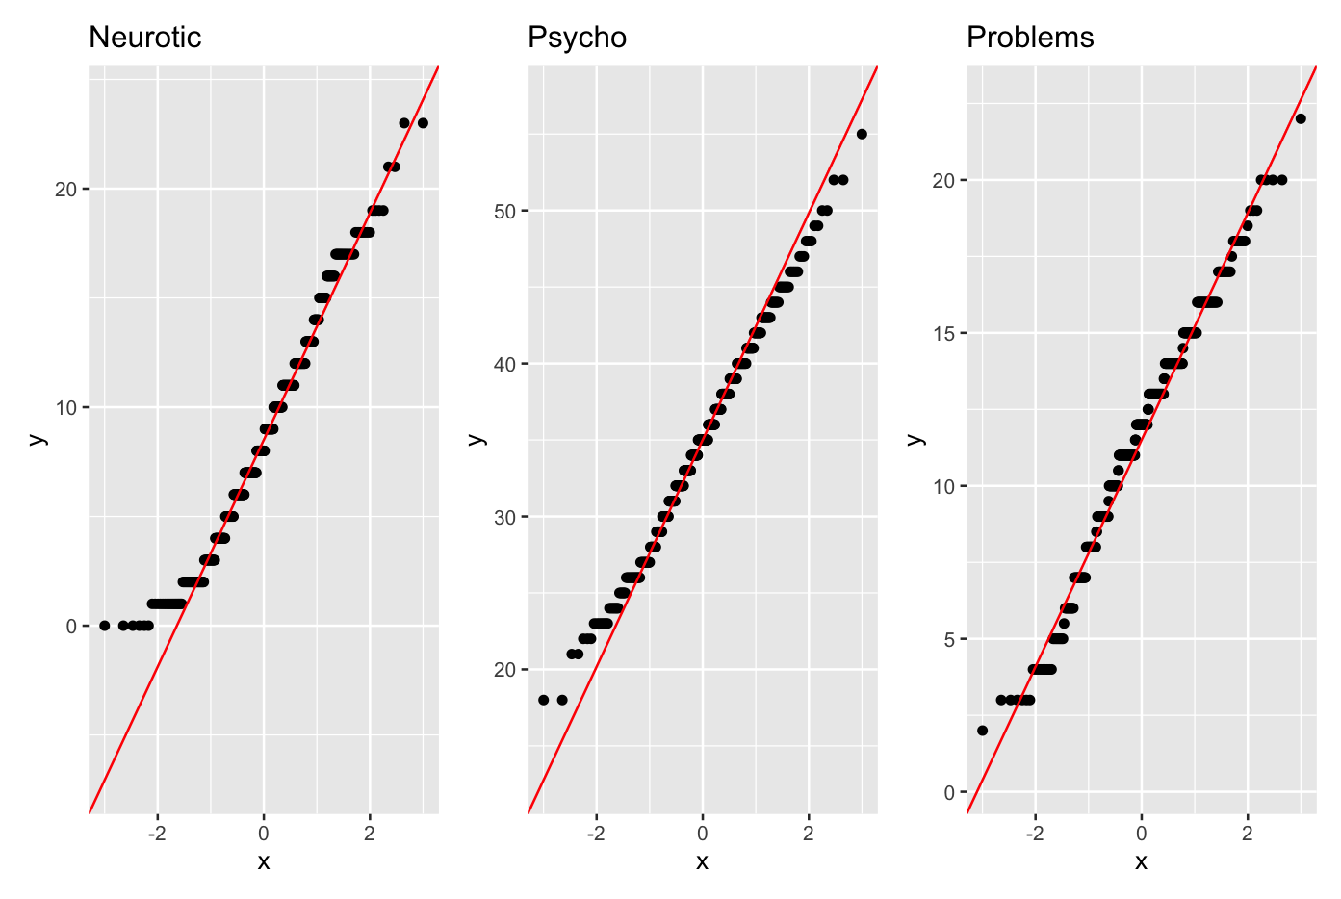
Numerically:
install.packages("DescTools")
library(DescTools)
Skew(df_a$Neurotic, method = 1, conf.level = .95) # neurotic 0.32
Skew(df_a$Psycho, method = 1, conf.level = .95) # psycho 0.06
Skew(df_a$Problems, method = 1, conf.level = .95) # problems -0.27

Kurt(df_a$Neurotic, method = 1, conf.level = .95) # neurotic -0.57
Kurt(df_a$Psycho, method = 1, conf.level = .95) # psycho -0.37
Kurt(df_a$Problems, method = 1, conf.level = .95) # problems -0.21

- Do any of the three measures include any extreme values (i.e., values that are greater or less than 3 SDs from the M)? If so, how many? Hint: see the last slide from this week’s lecture!
After checking three measures three measures’ extreme values, except for the Psycho variable’s extreme values with 317 extreme values, other two variables did not include any extreme values.

Neurotic <- mean(df$Neurotic) + 3*sd(df$Neurotic)
Neurotic #23.71 upper-bond
Neurotic_hout <- which(df$Neurotic >= Neurotic)
Neurotic_hout #0

Neurotic <- mean(df$Neurotic) - 3*sd(df$Neurotic)
Neurotic #-6.299 lower-bond
Neurotic_hout <- which(df$Neurotic <= Neurotic)
Neurotic_hout #0

Psycho <- mean(df$Psycho) + 3*sd(df$Psycho)
Psycho #23.71 upper-bond
Psycho_hout <- which(df$Psycho >= Psycho)
Psycho_hout #317

Psycho <- mean(df$Psycho) - 3*sd(df$Psycho)
Psycho #15.037 lower-bond
Psycho_hout <- which(df$Psycho <= Psycho)
Psycho_hout #0

Problems <- mean(df$Problems) + 3*sd(df$Problems)
Problems #22.85 upper-bond
Problems_hout <- which(df$Problems >= Problems)
Problems_hout #0

Problems <- mean(df$Problems) - 3*sd(df$Problems)
Problems #0.51 lower-bond
Problems_hout <- which(df$Problems <= Problems)
Problems_hout #0

- What is the margin of error (MOE) for each of the three variables.
The three variables’ margin of errors (MOE) are 0.5102914, 0.6772845, 0.3800134.

m.neurotic <- mean(df$Neurotic)
m.neurotic # 8.704607
sigma <- sd(df$Neurotic) # 5.0
n <- length(df$Neurotic) #369
conf <- 95
alpha <- (100 - conf)/100
se.neurotic <- sigma/n**.5
moe <- se.neurotic*qnorm(1-alpha/2)
moe # 0.5102914

m.psycho <- mean(df$Psycho)
m.psycho # 8.704607
sigma <- sd(df$Psycho) # 5.0
n <- length(df$Psycho) #369
conf <- 95
alpha <- (100 - conf)/100
se.psycho <- sigma/n**.5
moe <- se.psycho*qnorm(1-alpha/2)
moe # 0.6772845

m.problems <- mean(df$Problems)
m.problems # 8.704607
sigma <- sd(df$Problems) # 5.0
n <- length(df$Problems) #369
conf <- 95
alpha <- (100 - conf)/100
se.problems <- sigma/n**.5
moe <- se.problems*qnorm(1-alpha/2)
moe # 0.3800134

- Describe the three measures in APA style. Specifically, report the range (minimum and maximum scores), mean, and 95% CIs for each measure. Be sure to include a topic sentence that provides information about the measures and the sample, and use complete sentences!

Participants’ self-reported neuroticism, psychopathic traits, and internalizing and externalizing behaviors were assessed in a sample of 369 adolescents. Neuroticism scores ranged from 0 to 23 (M = 8.71, 95% CI [8.19, 9.22]). Psychopathic trait scores ranged from 18 to 55 (M = 34.95, 95% CI [34.27, 35.63]). Internalizing and externalizing problem scores ranged from 2 to 22 (M = 11.68, 95% CI [11.30, 12.06]).

summary(df$Neurotic) # range [0, 23], mean = 8.705
summary(df$Psycho) # range [18, 55], mean = 34.95
summary(df$Problems) # range [2, 22], mean = 11.68

t.test(df$Neurotic, conf.level = 0.95)$conf.int # [8.19,9.22]
t.test(df$Psycho, conf.level = 0.95)$conf.int # [34.27, 35.63]
t.test(df$Problems, conf.level = 0.95)$conf.int # [11.30, 12.06]

Part B: Perform bivariate statistical tests
The appropriateness of bivariate statistical tests depends on the type of variables (continuous or discrete) and the research goal (i.e., examining associations or testing differences). Independent samples t-tests are used to test whether the mean of a continuous variable differs as a function of a dichotomous variable (i.e., a discrete variable consisting of two groups). Paired sample t-tests are used to examine whether the means of two continuous variables from a single sample differ. Chi-square independence tests are used to examine the association between two discrete (categorical) variables. Correlations, which are the topic of the next lecture and assignment, are used to test the association between two continuous variables (as well as between a continuous and a dichotomous variable).
In addition to the three continuous variables examined in Part A, this assignment also involves three dichotomous variables in the dataframe. The first indicates the sex of each participant (Gender) and the remaining two variables classify adolescents’ reports of parenting styles into high and low responsiveness (Response) and into high and low demandingness (Demand). Answer the following questions involving these six variables.
- What type of analysis is most appropriate for testing the following research questions?
  - Is parental responsiveness associated with parental demandingness? Stated differently, do adolescents who report that their parents are responsive also indicate that their parents are demanding? correlation test

  - Do adolescents report higher levels of problem behaviors or neuroticism? t-test

  - Do adolescent females report more psychopathic traits than males? t-test

  - Do adolescents with highly responsive parents report less problem behaviors than those with less responsive parents? t-test

  - Are adolescent females more likely to report having demanding parents compared to males? chi-squre

- Provide the R code that tests all five research questions posed in question 5.

head(df)
str(df)

# change the type of these variables from chr to factor to numeric
df$n_Response <- NA
df$n_Response[df$Response == "low"] <- 0
df$n_Response[df$Response == "high"] <- 1

df$n_Demand <- NA
df$n_Demand[df$Demand == "low"] <- 0
df$n_Demand[df$Demand == "high"] <- 1

# a the relationship between parental responsiveness and parental demandingness
cor.test(df$n_Response, df$n_Demand,
method = "pearson",
conf.level = 0.95) # p = .94 not significant

# b problem and neurotic problem in adolescent
t.test(df$Problems, df$Neurotic, # problems - neurotic
paired = TRUE,
conf.level = 0.95) # p < .001, [2.32, 3.63] significant
# sample estimates = mean difference 2.97561 on average, problems is higher than neurotic with 2.98

# c psycho difference across gender
head(df)
t.test(Psycho ~ Gender, data = df,
conf.level = 0.95) # p = .65 > .05 CI includes zero => no difference

# d relationship between higher responsiveness and less problems
str(df)
df$f_Response <- as.factor(df$Response)
t.test(Problems ~ f_Response, data = df,
conf.level = 0.95) # p = .02 < .05 10.94 > 11.99 => low responsiveness = higher problems

# e demaning parents difference across gender
str(df)
table(df$Gender, df$Demand)
chisq.test(table(df$Gender, df$Demand)) # p = .11 < .05 no difference

- Homogeneity of variance is a statistical assumption for t-tests (and other statistical analyses that included a continuous dependent variable…more on this later). How is a potential violation of this assumption dealt with in the t.test() function in R?

In R, t.test() function defaultingly handles the Welch’s t-test without homogeneity of variance:
var.equal = FALSE showing that this command takes the Welch’s t-test rather than the Student’s t-test with homogeneity of variance.

Part C: Write it up!
While the importance of performing the appropriate analyses cannot be overstated, it is equally important to be able to report and interpret the results of statistical analyses. While different writing “styles” exist, we will focus on reporting results in APA style. The Publication Manual of the American Psychological Association (7th edition) includes all information regarding the structure of writing scientific reports, including the reporting of results from statistical analyses and formatting of references. Several websites provide information regarding APA style (e.g., https://owl.purdue.edu/owl/research_and_citation/apa_style/apa_formatting_and_style_guide/statistics_in_apa.html). For the following items, perform the appropriate analyses and report the results in APA style. Be sure to use complete sentences, report the relevant values, and use italics and capitalization appropriately.
- Do adolescents with demanding parents report higher levels of neuroticism than those with less demanding parents?
An independent-samples t test was conducted to examine whether adolescents with demanding parents reported higher neuroticism than those with less demanding parents. Adolescents in the high-demanding group (M = 9.18, SD = 5.12) did report significantly higher neuroticism than those in the low-demanding group (M = 7.76, SD = 4.64), t(269.51) = 2.69, p = .008, 95% CI [0.38, 2.47], Cohen’s d = 0.29.

- Do adolescent reports of problem behaviors differ as a function of gender?
An independent-samples t test was conducted to examine whether problem behaviors differed by gender. Females (M = 10.25, SD = 3.34) reported lower problem behaviors than males (M = 13.15, SD = 3.53), t(364.44) = -8.1288, p < .001, 95% CI [-3.61, -2.20], Cohen’s d = -0.85.

- Do adolescent females report having responsive parents more often than adolescent males?
A chi-square test of independence was conducted to examine whether females reported having responsive parents more often than males. The association between gender and parental responsiveness was not significant, χ²(1, N = 369) = 1.7426, p = .1868. Females reported high parental responsiveness 32.62% of the time, compared with 25.82% of males.

- Create a multiple-choice exam question with 4 answer options (1 of them the correct answer, please indicate which one) that you think is a good way to test the content of this week.
A researcher conducts an independent-samples t test in R using the default t.test() function and obtains df = 195.35. Which of the following best explains why the degrees of freedom are not a whole number?

A. R automatically applied a Bonferroni correction, which adjusts the degrees of freedom.
B. R used Welch's t-test, which does not assume equal variances and adjusts the degrees of freedom using the Welch–Satterthwaite equation.
C. R detected missing values and estimated the degrees of freedom using maximum likelihood.
D. R used a paired-samples t test, which always produces fractional degrees of freedom.

